Part 1

1. print("Ahmed)

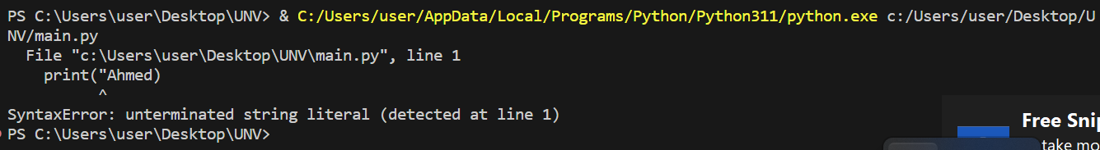

In this program, error appeared because of using string data type with just one quotation mark.

1. print(10 \* 2)

print(10 \*\* 2)

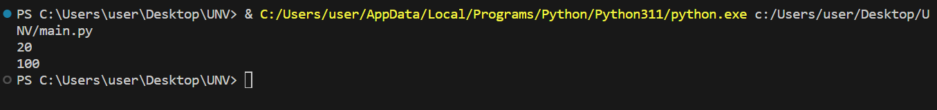

The difference between \* and \*\* operators as appeared in this example is single star operator represent multiplication, however double stars represent power or exponent.

1. print(09)

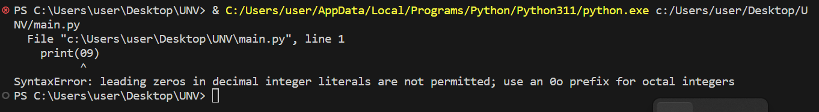

In python it is not allowed to lead zero for decimal integer. You can used with octal integer.

1. print('67')

print(67)

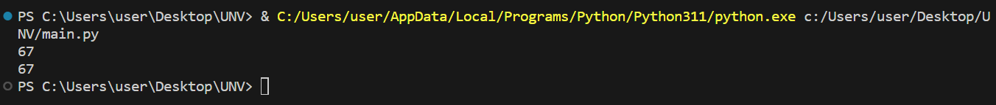

The difrrence between to result is that the first output is just string, but the second on is int (number) so you can do operator on it like addition, subtraction, multiplication, and so on.

Part 2

1. print("my age is :")

print(22 \* 2)



The program use print() function twice, first to clarify this is my age, second to print my age multiplied by 2.

1. print("I live in eastern Assyut in Assyut city in Egypt which fill within Africa")



The program shows my adress.

1. print("This term start 16th Nov and end at 14th Feb")



The output is a string clarify the start and the end of current term.

D. print("The temperature today is 64 F")



The output is the result of using string in print function.